Name__Pratik Rauniyar____________ Mark _____________________/50

1. Brief introduction __/3
This document details the design and implementation of gameplay and combat mechanics for the combat-based game I am developing. The core focus of the project revolves around creating an immersive and dynamic combat experience, integrating core movement mechanics, hit detection systems, and complex combo & special move mechanics to deliver engaging player interactions. I will be focused on activities like core Movement (jump, crouch, dash, kick, roll & kick, etc), hit detection & collision logic and combos & special move mechanics which will make the game more interesting and involving.

2. Use case diagram with scenario __14

Use case diagram :
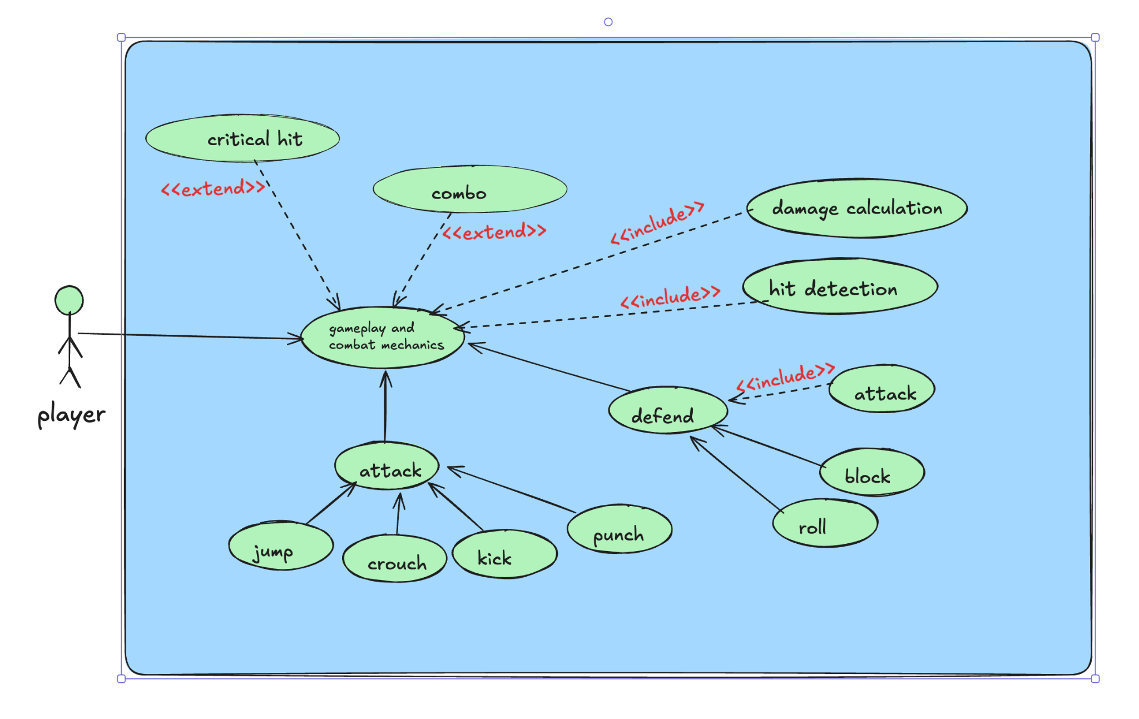

Use Case Diagrams

Scenarios
Scenario for Gameplay and combat mechanics
Name: Gameplay and combat mechanics
Summary:The player engages in combat using a combination of core movement and attack/defend mechanics. The player can jump, crouch, dash, kick, and punch during combat while defending with block or roll.
Actors: Players.
Preconditions: The game is on and the player is within the combat area with at least one enemy present.
Basic sequence:
Step 1: The player enters combat mode and can perform movement actions (e.g., Jump, Crouch, Dash).
Step 2: The player selects either an attack or defend move (e.g., Punch, Kick, Block, Roll).
Step 3: If the player attacks, the attack move is executed, and the hit detection logic checks whether the attack lands on the enemy. If the attack hits, the damage is calculated, and the enemy’s health is reduced.
Step 4: If the player defends (e.g., Block or Roll), the defense is executed. The damage is either mitigated or completely avoided based on the type of defense move.
Step 5 : The player may also perform a combo of attacks, where a series of button presses triggers a sequence of attacks with increasing damage. Alternatively, a critical hit may be triggered for extra damage.
Step 6 : The player continues to fight until one of the combatants (player or enemy) loses all health, or the battle objectives are achieved.
Exceptions:
Step 1: If the player is not in combat mode, combat actions are not available, and the player must enter combat mode.
Step 2: If the player is knocked down or incapacitated, they temporarily cannot perform any attack or defense action.
Post conditions: The player's actions (movement, attack, or defense) are executed according to the sequence.
Priority: 1*
ID: C01
*The priorities are 1 = must have, 2 = essential, 3 = nice to have.

Scenario for Attack
Name: Perform Attack
Summary: The player performs an attack action (such as Punch, Kick, Jump Attack) to damage the enemy.
Actors: Player
Preconditions:
The player is in combat mode.
The enemy is within range of the player’s attack.
Basic sequence:
Step 1: The player selects an attack move (e.g., Punch, Kick).
Step 2: The player presses the corresponding attack button.
Step 3: The attack move is executed, and the player’s character performs the animation for the selected move.
Step 4: The attack hits the enemy if the player is within the required range and no defense actions (like a block or roll) are in place from the enemy.
Step 5: The damage is calculated based on the attack type and player stats.
Step 6: The enemy takes damage, and the health bar is updated.
Step 7: The attack animation completes, and the player can continue attacking or defending.
Exceptions:
Step 1: If the player is out of range, the attack does not land. A message is displayed indicating the attack missed.
Step 2: If the wrong button is pressed, no attack is performed, and the player may perform a different move (e.g., a movement action).
Step 3: If the attack is blocked by the enemy or a defense action is in place, the attack does minimal or no damage.
Step 4: If the player’s energy is too low, the attack cannot be executed.
Post conditions:
The enemy’s health is reduced by the calculated damage.
The attack animation finishes, and the player has the option to continue the next action.
Priority: 1
ID: A01
*The priorities are 1 = must have, 2 = essential, 3 = nice to have.

Scenario for Defend
Name: Perform Defend
Summary: The player performs a defensive action (such as Block or Roll) to reduce or avoid incoming enemy attacks.
Actors: Player
Preconditions:
The player is in combat mode.
The enemy is in the process of attacking.
Basic sequence:
Step 1: The player selects a defense action (e.g., Block or Roll).
Step 2: The player presses the corresponding button for defense.
Step 3: The defense action is executed, and the player’s character performs the animation for the selected move.
Step 4: If the player blocks, incoming damage is reduced based on the defense value of the block. If the player rolls, the attack is evaded entirely if timed correctly.
Step 5: The player’s health is updated, with damage reduced or avoided if the defense was successful.
Step 6: The defense action finishes, and the player can resume attacking or moving.
Exceptions:
Step 1: If the player does not select a defense action, no defense is performed, and the player takes full damage from the incoming attack.
Step 2: If the defense button is pressed too early or too late, the player may not properly block or evade the attack.
Step 3: If the player is in the middle of another action (e.g., attacking), the defense action may be canceled or delayed.
Step 4: If the player is in the air or stunned, no defense action can be executed.
Post conditions:
If the player successfully blocks, incoming damage is reduced according to the defense mechanics.
If the player successfully rolls, the incoming attack is completely avoided.
The player can continue with their next action (attack or movement) once the defense animation finishes.
Priority: 1
ID: D01
*The priorities are 1 = must have, 2 = essential, 3 = nice to have.

Scenario for Hit Detection (Include Use Case)
Name: Hit Detection
Summary: The system checks if an attack has successfully hit the enemy, determining whether the attack lands within the correct hit box.
Actors: Game System
Preconditions:
The player has performed an attack action (e.g., Punch, Kick).
The enemy is within the attack range and in combat mode.
Basic sequence:
Step 1: The player performs an attack move (e.g., Punch, Kick).
Step 2: The system checks the distance and position between the player and the enemy.
Step 3: The system checks the hit box of the player’s attack against the enemy’s hit box.
Step 4: If the hit box of the attack intersects with the enemy’s hit box, the attack is considered a successful hit.
Step 5: If the attack successfully hits, the damage calculation step is triggered.
Step 6: If the attack misses (i.e., no intersection between the hit boxes), the attack is considered a miss, and no damage is inflicted.
Exceptions:
Step 1: If the enemy is out of range of the attack, the attack does not hit, and a message is displayed indicating the attack missed.
Step 2: If the enemy is blocking or rolling, the hit detection may register as no damage or partial damage.
Post conditions:
The system identifies whether the attack hit the enemy or missed.
If a hit occurs, the system proceeds to the damage calculation step.
If the attack misses, the player’s turn ends, and the enemy may retaliate.
Priority: 1
ID: HD01
*The priorities are 1 = must have, 2 = essential, 3 = nice to have.

Scenario for Damage Calculation (Include Use Case)
Name: Damage Calculation
Summary: The system calculates the damage inflicted on the enemy when an attack lands successfully, factoring in the type of attack, player stats, and any special conditions (e.g., critical hit).
Actors: Player, Enemy (Antagonist)
Preconditions:
The player’s attack has successfully hit the enemy (as verified by hit detection).
The enemy has health remaining and is still in combat mode.
Basic sequence:
Step 1: The hit detection confirms the attack has landed.
Step 2: The system retrieves the attack type (e.g., Punch, Kick, Special Move) and the player’s stats (e.g., Attack Power, Critical Hit chance).
Step 3: The system checks if the attack was a critical hit based on the player’s stats and luck chance. If a critical hit occurs, the damage is increased.
Step 4: The system calculates the base damage for the attack using the attack type and player stats.
Step 5: The system factors in any additional modifiers such as critical hits, combos, or buffs.
Step 6: The calculated damage is subtracted from the enemy’s health.
Step 7: The damage value is displayed in the form of a hit number (e.g., “Enemy hit for 15 damage!”).
Exceptions:
Step 1: If the player’s attack power is too low, the damage calculation may result in minimal or no damage.
Step 2: If the enemy has a defense modifier, the damage will be reduced based on the defense value.
Step 3: If the enemy’s health is reduced to 0 or below, the enemy is defeated, and the battle ends.
Post conditions:
The enemy’s health is updated based on the calculated damage.
The attack damage is displayed, and the player can proceed with the next action (attack, defend, or movement).
If the enemy is defeated, the battle ends, and the player progresses to the next phase.
Priority: 1
ID: DC01
*The priorities are 1 = must have, 2 = essential, 3 = nice to have.

Scenario for Critical Hit (Extend Use Case)
Name: Critical Hit
Summary: The player’s attack has the chance to land a critical hit, dealing additional damage based on certain conditions such as player stats or luck.
Actors: Player
Preconditions:
The player has performed an attack move that is capable of landing a critical hit (e.g., Punch, Kick, Special Move).
The player has a critical hit chance based on their stats (e.g., Luck, Critical Hit Rate).
Basic sequence:
Step 1: The player performs an attack move in the critical body parts of the enemy.
Step 2: The system checks the player's critical hit chance using player stats.
Step 3: If the system determines a critical hit based on player stats, the damage value is multiplied by a critical hit factor (e.g., 2x or 3x).
Step 4: The attack damage is updated to reflect the critical hit value.
Step 5: The enemy takes the increased damage based on the critical hit value.
Step 6: The critical hit is displayed as part of the attack animation or as a message (“Critical Hit!”).
Exceptions:
Step 1: If the player’s critical hit chance is too low, no critical hit occurs, and the damage calculation proceeds normally.
Step 1: If the player’s critical hit chance is temporarily disabled (e.g., a debuff), the critical hit does not occur.
Step 3: If the player’s attack power is too low, the critical hit may still not result in a significant damage boost.
Post conditions:
The enemy takes the increased damage due to the critical hit.
The attack is logged with the critical hit factor, and the player can proceed with the next action.
If the enemy’s health reaches 0, the enemy is defeated, and the battle progresses.
Priority: 2
ID: CH01
*The priorities are 1 = must have, 2 = essential, 3 = nice to have.

Scenario for Combo (Extend Use Case)
Name: Combo Attack
Summary: The player performs a series of attacks in quick succession to trigger a combo, dealing extra damage for each consecutive hit.
Actors: Player
Preconditions:
The player has performed an attack move that is part of a combo (e.g., Punch, Kick, Special Move).
The player must input the correct sequence of attack commands (e.g., Punch > Kick > Punch) within a specific timeframe to trigger the combo.
Basic sequence:
Step 1: The player starts the combo by performing the first attack move (e.g., Punch).
Step 2: The player quickly performs the next move in the combo sequence (e.g., Kick).
Step 3: The player successfully lands the combo sequence within the allowed timeframe, triggering the combo damage calculation.
Step 4: Each consecutive hit in the combo adds bonus damage, increasing the damage for each subsequent attack.
Step 5: The total combo damage is calculated and displayed as a sum of individual hit damages.
Step 6: The combo attack is shown in the form of a special animation or visual effects.
Step 7: The enemy receives the combined damage from all successful combo hits.
Exceptions:
Step 1: If the player fails to input the correct sequence within the time limit, the combo is canceled, and the attack sequence proceeds normally.
Step 2: If the enemy blocks or evades part of the combo, the damage may be reduced or canceled for that specific hit.
Step 3: If the player is interrupted (e.g., by a stun or knockdown), the combo may be prematurely ended.
Post conditions:
The enemy receives the calculated combo damage, with additional damage per successful hit.
The combo animation is completed, and the player can proceed to the next action.
If the enemy’s health reaches 0, the enemy is defeated, and the battle progresses.
Priority: 3
ID: CO01
*The priorities are 1 = must have, 2 = essential, 3 = nice to have.

3. Data Flow diagram(s) from Level 0 to process description for your feature _______14
Data Flow Diagrams
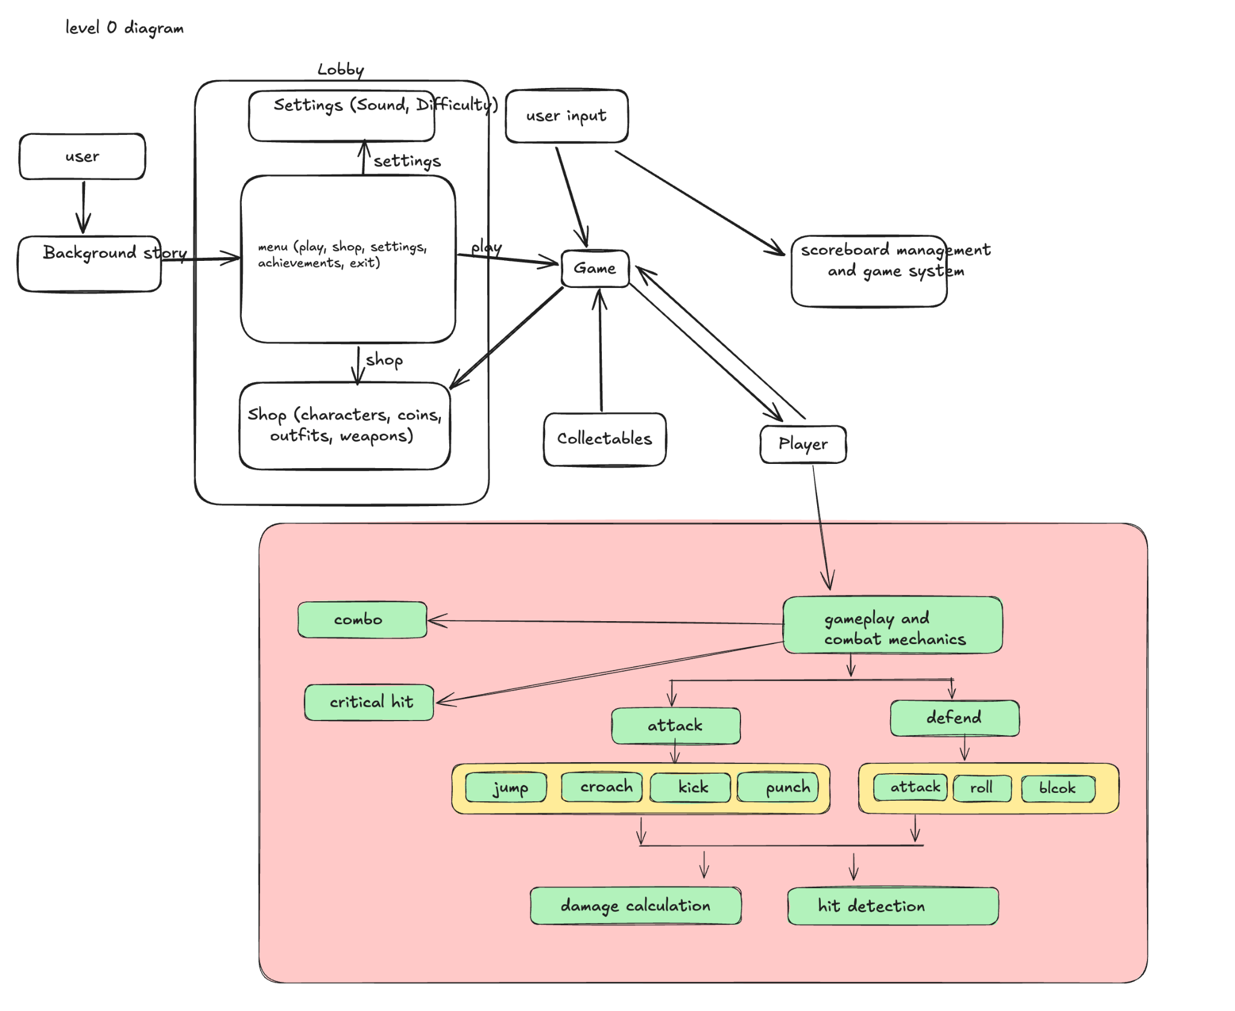

Process Descriptions
Process Description for Gameplay and Combat Mechanics
1. Player Input Handling
Trigger: The player provides input via keyboard, controller, or touch interface.
Process:
The system captures player input (e.g., movement, attack, defense).
The input is processed to determine the action (jump, crouch, attack, block, etc.).
If the input corresponds to a valid combat action, it is passed to the respective combat mechanics module.
Output: The player's action is executed, triggering animations and system calculations.

2. Movement System
Trigger: The player presses a movement key (jump, crouch, dash, roll).
Process:
The system checks if movement is allowed (e.g., player is not stunned).
The movement is executed based on the player's direction and input.
If applicable, special movement animations or physics (e.g., momentum for dashes) are applied.
Output: The player moves in the game environment.

3. Attack System
Trigger: The player presses an attack button.
Process:
The system verifies that the player is in combat mode.
The attack animation is triggered.
The hit detection module is activated to check if the attack lands.
If successful, the damage calculation module processes the inflicted damage.
If the attack is part of a combo sequence, the combo module is triggered.
Output: The enemy receives damage if the attack lands, and the player's action is recorded.

4. Defense System
Trigger: The player presses a block or roll button.
Process:
The system checks if the player is in combat mode.
The defense animation is triggered.
If blocking, the system calculates damage reduction.
If rolling, the system determines if the evasion is successful.
Output: The player's defense action is executed, and damage is mitigated or avoided.

5. Hit Detection System
Trigger: An attack is performed.
Process:
The system retrieves the attack's hitbox coordinates.
The system retrieves the enemy’s hitbox coordinates.
A check is performed to determine if the hitboxes intersect.
If an intersection occurs, the attack is registered as a hit.
If no intersection occurs, the attack is considered a miss.
Output: The attack either lands and proceeds to damage calculation or misses.

6. Damage Calculation System
Trigger: An attack successfully lands.
Process:
The system retrieves attack type and player stats.
The system checks if any modifiers apply (e.g., critical hit, buffs).
The base damage is calculated based on attack strength and enemy defense.
The final damage is subtracted from the enemy’s health.
Output: The enemy’s health is updated, and the result is displayed on-screen.

7. Critical Hit System
Trigger: A critical hit chance is determined during damage calculation.
Process:
The system retrieves the player’s critical hit rate.
A probability check determines if a critical hit occurs.
If successful, the damage multiplier is applied.
Output: The attack deals extra damage, and a visual effect or text appears.

8. Combo System
Trigger: The player executes a predefined sequence of attacks.
Process:
The system verifies if the combo sequence is valid.
Each attack in the sequence is executed in rapid succession.
A damage multiplier is applied for each successful hit.
The final combo damage is calculated.
Output: The enemy takes cumulative damage, and a combo animation or visual effect is displayed.

9. Health and Battle State Management
Trigger: Player or enemy receives damage.
Process:
The system updates the health bar based on damage received.
If health reaches zero, the character is defeated.
If the enemy is defeated, the battle concludes, triggering the win/loss state.
Output: The battle progresses or ends based on health status.

4. Acceptance Tests ________9
Acceptance Test for Gameplay and Combat Mechanics

Test Case: Entering Combat Mode
Test ID: TC01
Description: Ensure the player can enter combat mode when an enemy is present.
Preconditions: The player is in the game world, and at least one enemy is nearby.
Test Steps:
Move the player near an enemy.
Press the combat initiation button.
Expected Result: The player enters combat mode, and combat mechanics become available.
Pass Criteria: The player successfully enters combat mode, and movement/attack options appear.

Test Case: Performing Attack
Test ID: TC02
Description: Verify that the player can perform an attack.
Preconditions: The player is in combat mode and within attack range of an enemy.
Test Steps:
Press the attack button (e.g., Punch, Kick).
Observe if the attack animation plays.
Check if hit detection registers the attack.
Expected Result: The attack is executed, and if it lands, the enemy takes damage.
Pass Criteria: The attack animation plays, hit detection registers the hit, and enemy health decreases if hit is successful.

Test Case: Performing Defense (Block/Roll)
Test ID: TC03
Description: Ensure the player can perform a defensive action.
Preconditions: The player is in combat mode, and the enemy is attacking.
Test Steps:
Press the defense button (Block/Roll) as the enemy attacks.
Observe if the defense animation plays.
Check if damage is reduced (Block) or avoided (Roll).
Expected Result: The player successfully blocks (reducing damage) or rolls (evading the attack).
Pass Criteria: Defense animation plays, and damage is mitigated or avoided based on defense type.

Test Case: Hit Detection
Test ID: TC04
Description: Validate that hit detection correctly registers hits and misses.
Preconditions: The player is in combat mode, and an attack is performed.
Test Steps:
Execute an attack while within range of the enemy.
Execute an attack while outside the range of the enemy.
Observe the hit/miss detection result.
Expected Result: The system correctly registers hits when the attack is within range and misses when the attack is out of range.
Pass Criteria: The attack only lands if within range, and misses if out of range.

Test Case: Damage Calculation
Test ID: TC05
Description: Verify that damage calculation is accurate.
Preconditions: A successful hit has been detected.
Test Steps:
Perform an attack and check the enemy’s initial health.
Check the attack damage value.
Verify that the enemy’s health decreases correctly.
Expected Result: The enemy’s health decreases based on the damage calculation formula.
Pass Criteria: The enemy’s health updates correctly after each successful attack.

Table for critical Hit activation
Output | Player Action | Notes | Expected Result
Attack Executed | Perform an attack with a critical hit chance. | The attack is initiated and has a chance to be a critical hit. | Attack animation plays, and hit detection is triggered.
Critical Hit Check | System determines if an attack is critical. | The game runs a probability check to determine a critical hit. | Critical hit triggers occasionally based on probability.
Damage Calculation | Verify if critical hit damage is applied. | If a critical hit is triggered, the damage is multiplied. | Critical hit deals increased damage.
UI Feedback | Observe damage numbers on screen. | Critical hits should display a unique color or effect. | UI shows the boosted damage with a special indicator.
Enemy Reaction | Enemy takes damage from the critical hit. | Enemy’s health decreases based on the critical hit damage value. | Enemy's HP reduces according to the critical hit multiplier.

Table for combos

Output | Player Action | Notes | Expected Result
Combo Initiated | Input a valid combo sequence within the time limit. | The player performs a series of attacks within the combo window. | The game detects the combo input.
Combo Progress | Continue pressing attack buttons in sequence. | Each correct input extends the combo chain. | The combo animation progresses smoothly.
Damage Stacking | Observe if increased damage is applied. | Each hit in the combo should deal more damage or apply effects. | Damage scales up with each successive hit.
Animation Chain | Observe smooth transitions between moves. | Each move should transition seamlessly into the next. | The combo executes fluidly without interruption.
UI Feedback | Display combo counter or special effects. | The UI should indicate the combo sequence (e.g., a counter). | UI shows a combo counter or special indicator.
Enemy Reaction | Enemy takes hits and reacts accordingly. | The enemy should stagger or react dynamically to the combo. | Enemy receives consecutive hits with appropriate reactions.

5. Timeline _________/10

Work items

Work Items | Task | Duration (PWks) | Predecessor Task(s)
1. Core Movement System | Jump, Crouch, Dash, Roll, Kick | 2 | -
2. Hit Detection & Collision | Implement and refine collision detection | 3 | 1
3. Combat Basics | Basic attack mechanics, blocking, dodging | 3 | 1
4. Combo System | Chain attacks & special move mechanics | 3 | 3
5. Tactical Item Mechanics | Implement power-ups, health recovery, equipment use | 2 | 3
6. AI Enemy Behavior | Design AI responses to attacks & movement | 1 | 3
7. Playtesting & Balancing | Adjust damage values, hitboxes, speed, etc. | 2 | 2, 4, 5, 6
8. Final Integration | Ensure smooth integration of all mechanics | 2 | 7
9. Debugging and testing | Test the feature and debug the program in presence of any errors. | 1 | 8
10. Documentation | Document each part for easy understanding. | 1 | 9

Pert diagram

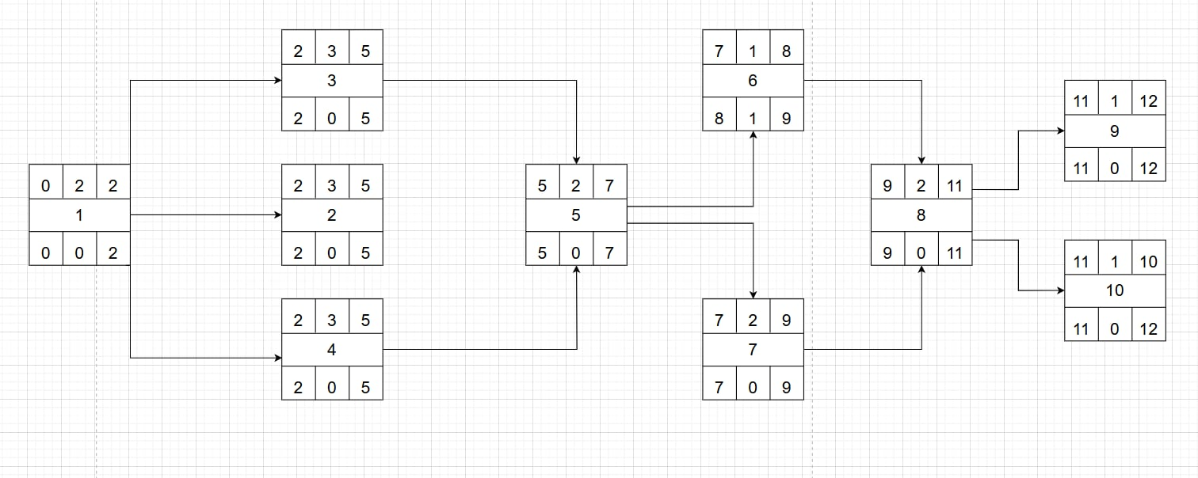

Gantt timeline
1 | ⭐
2
3
4
5
6
7
8
9
10
 | 1 | 2 | 3 | 4 | 5 | 6 | 7 | 8 | 9 | 10 | 11 | 12 | 13 | 14 | 15 | 16 | 17 | 18 | 19 | 20 | 21 | 22 | 23 | 24 | 25 | 26 | 27

